Week9 Project
1. Summarize the Given Problem
The Stack Overflow dataset contains information related to technical discussions and graph database topics. The dataset includes questions, answers, comments, tags, and users collected from Stack Overflow. The objective is to design a database solution that organizes these entities efficiently and supports analytical reporting through a dashboard. The solution must allow users to explore discussion topics, identify frequently used tags, analyze answer activity, and examine relationships among questions, answers, comments, and users. The database should support efficient storage, retrieval, and visualization of the data while maintaining data integrity and scalability.
2A. Attributes and Associations for the Data Model
1) User Entity
Attributes:
- user_id INTEGER (Primary Key)
- uuid INTEGER
- display_name VARCHAR(255)
Association:
- Users create and contribute content within the Stack Overflow platform.
- User information is associated with questions, answers, and comments.
2) Question Entity
Attributes:
- question_id INTEGER (Primary Key)
- accepted_answer_id INTEGER (Foreign Key → Answer.answer_id)
- creation_date TIMESTAMP
- view_count INTEGER
- answer_count INTEGER
- body_markdown TEXT
- uuid INTEGER
- title TEXT
- link TEXT
Association:
- Questions may have one accepted answer.
- Questions are categorized using tags.
- Questions receive answers and comments from users.
3) Answer Entity
Attributes:
- answer_id INTEGER (Primary Key)
- title TEXT
- is_accepted BOOLEAN
- body_markdown TEXT
- score INTEGER
- uuid INTEGER
- link TEXT
Association:
- Answers provide responses to questions.
- Answers may be marked as accepted solutions.
- Answers can receive comments and user feedback.
4) Comment Entity
Attributes:
- comment_id INTEGER (Primary Key)
- score INTEGER
- uuid INTEGER
- link TEXT
Association:
- Comments provide additional discussion related to questions and answers.
- Comments allow users to clarify, explain, or provide feedback on posted content.
5) Tag Entity
Attributes:
- tag_id INTEGER (Primary Key)
- name VARCHAR(100)
- link TEXT
Association:
- Tags categorize questions according to technical topics.
- Multiple questions can be associated with the same tag.
- Tags help users search and filter content efficiently.
2B. Relationships between Entities
1) Question Answer
Relationship Type: One-to-Many (1: M)
Explanation: A question can receive multiple answers, while each answer belongs to a single question.
2) Question Comment
Relationship Type: One-to-Many (1:M)
Explanation: A question can have multiple comments.
3) Answer Comment
Relationship Type: One-to-Many (1:M)
Explanation: An answer can have multiple comments.
4) Question Tag
Relationship Type: Many-to-Many (M:M)
Explanation: A question may contain multiple tags, and each tag may be associated with many questions.
5) User Question
Relationship Type: One-to-Many (1:M)
Explanation: A user may create multiple questions.
6) User Answer
Relationship Type: One-to-Many (1:M)
Explanation: A user may create multiple answers.
7) User Comment
Relationship Type: One-to-Many (1:M)
Explanation: A user may create multiple comments.
3A. Entity Relationship Diagram (ERD)
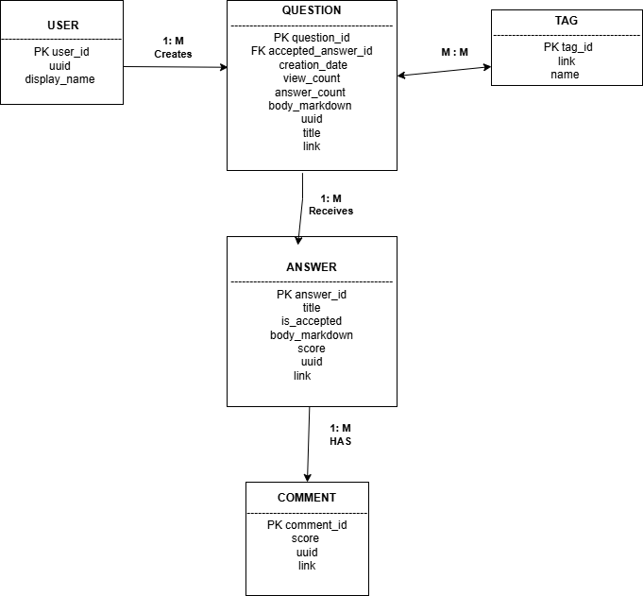
Figure1: ERD Diagram
The ERD illustrates the main entities in the Stack Overflow dataset, including User, Question, Answer, Comment, and Tag. Each entity contains attributes relevant to its role within the dataset. The diagram shows how users create questions, questions receive answers, answers receive comments, and questions are associated with tags. The ERD provides a structured view of the data model and helps identify relationships between entities that will be implemented within the database management system.
3B. Graph Model

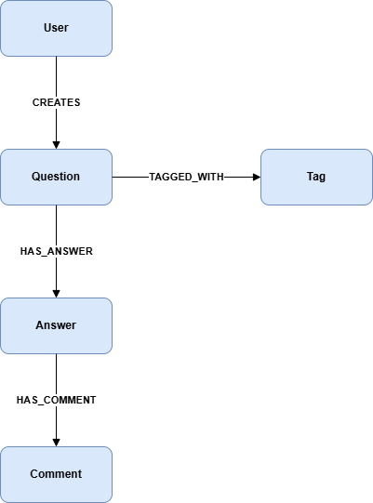
Figure2: Graph model
The graph model represents the dataset using nodes and relationships. In this model, User, Question, Answer, Comment, and Tag are represented as nodes. Relationships such as CREATES, HAS_ANSWER, HAS_COMMENT, and TAGGED_WITH connect the nodes and illustrate how the entities interact. This visualization emphasizes the interconnected nature of the data and provides an alternative perspective for understanding relationships within the dataset.
4. Evaluate the Data Model
The Stack Overflow dataset contains multiple structured entities with meaningful relationships. Questions, answers, comments, tags, and users represent separate entities that interact through one-to-many and many-to-many relationships. The dataset requires efficient querying, aggregation, filtering, and reporting. A relational model is appropriate because it minimizes redundancy through normalization while maintaining data integrity through primary key and foreign key constraints. The model also supports analytical operations needed for dashboard visualizations and frequency analysis. The relational model also supports referential integrity, efficient querying, and scalable storage for the Stack Overflow dataset.
5A. Why PostgreSQL Is Appropriate
PostgreSQL is appropriate because the dataset contains structured entities and clearly identifiable attributes. PostgreSQL supports primary keys, foreign keys, indexing, joins, aggregation functions, and advanced SQL queries. These features enable efficient analysis of questions, answers, comments, tags, and users. PostgreSQL also integrates well with dashboard tools and supports the analytical requirements of the project.
5B. Why Other Database Management Systems Are Less Appropriate
MongoDB
MongoDB is schema-flexible but is less suitable because the dataset contains multiple related entities. Maintaining relationships between questions, answers, comments, tags, and users would require embedding or referencing documents, which can increase complexity and data duplication.
Neo4j
Neo4j is well suited for highly connected graph data. However, the project focuses on reporting, aggregations, frequency distributions, dashboards, and structured analysis. PostgreSQL provides stronger support for these operations and is easier to use for generating analytical reports.
5C. How PostgreSQL Will Be Used
PostgreSQL will store the Stack Overflow dataset in normalized tables representing users, questions, answers, comments, and tags. SQL queries will be used to calculate metrics such as question counts, answer counts, popular tags, accepted answers, and user activity levels. The results will be displayed through dashboards and visualizations that help users analyze discussion trends and topic popularity.
Part Two: Integrate the Data Model
6. Implement the Designed Data Model within the Selected Database Management System
The designed data model was implemented using PostgreSQL, a relational database management system capable of storing, managing, and querying structured data efficiently. The implementation process involved creating a database, defining relational tables, and importing data from the Stack Overflow dataset into PostgreSQL.
The database, named stackoverflow_db, was created to store information related to users, questions, answers, comments, and tags.
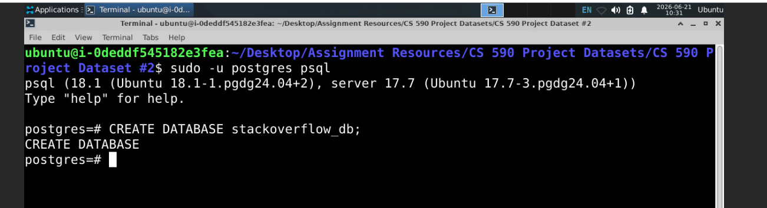
Figure3. Creation of the PostgreSQL database used for the project.
Five relational tables were implemented based on the data model developed in Part One:
- users
- questions
- answers
- comments
- tags
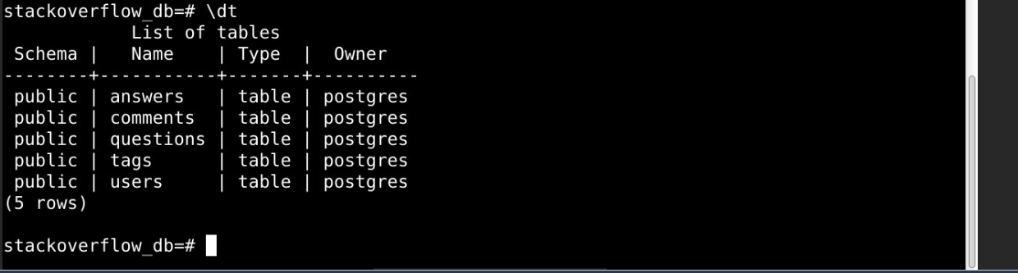

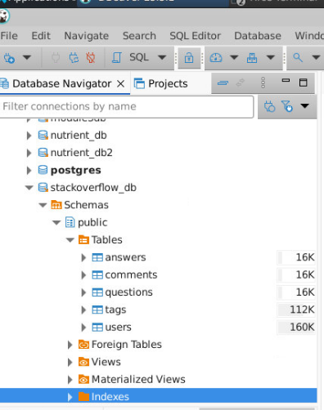
Figure4. PostgreSQL tables created from the Stack Overflow data model.
Each table was created using SQL Data Definition Language (DDL) statements. Primary keys were defined to uniquely identify records, and appropriate PostgreSQL data types were assigned to each attribute. The imported CSV files were then loaded into the corresponding database tables using PostgreSQL import functionality. After implementation, validation queries were executed to confirm that all records were successfully imported into the database.
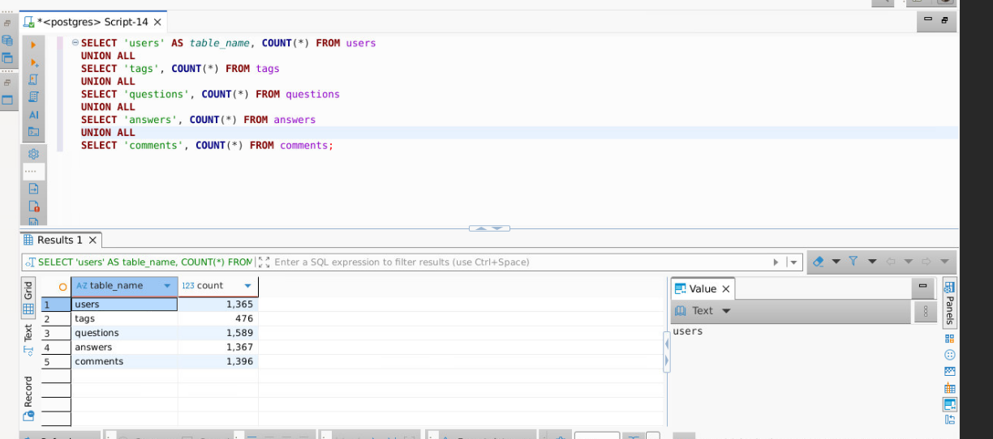
Figure5. Validation of imported records following implementation of the database design.
The completed database contained:
- Users: 1,365 records
- Questions: 1,589 records
- Answers: 1,367 records
- Comments: 1,396 records
- Tags: 476 records
The successful implementation of the data model provided the foundation for query execution, reporting, dashboard development, and database analysis activities completed throughout the remainder of the project.
A. How the Design Is Tailored to PostgreSQL
The data model was specifically designed for implementation within PostgreSQL. The relational structure aligns well with PostgreSQL’s support for tables, primary keys, indexing, and SQL-based querying. Large text fields such as body_markdown were stored using the TEXT data type, allowing PostgreSQL to efficiently manage lengthy Stack Overflow content. PostgreSQL also provides strong support for data integrity, scalability, indexing, backup management, and analytical query processing.
The normalized design reduces data redundancy and improves maintainability while allowing PostgreSQL to efficiently retrieve and analyze information across multiple tables. This makes PostgreSQL an effective platform for managing and analyzing the Stack Overflow dataset.
7. Design a Set of Test Queries to Validate the Data Model
A series of SQL test queries were designed to validate the functionality, accuracy, and integrity of the Stack Overflow database. These queries verify successful data loading, record retrieval, and analytical processing capabilities.
Query 1: Record Count Validation
SELECT 'users' AS table_name, COUNT(*) FROM users
UNION ALL
SELECT 'tags', COUNT(*) FROM tags
UNION ALL
SELECT 'questions', COUNT(*) FROM questions
UNION ALL
SELECT 'answers', COUNT(*) FROM answers
UNION ALL
SELECT 'comments', COUNT(*) FROM comments;
Purpose: A COUNT(*) query was executed against each table to verify that the records were imported successfully.
Query 2: Validate Question Records
SELECT COUNT(*) AS total_questions
FROM questions;
Purpose: Verifies that question records were imported successfully into the Question table.
Query 3: Retrieve Tag Information
SELECT tag_id, name
FROM tags
ORDER BY tag_id
LIMIT 10;
Purpose: Verifies that tag information can be retrieved successfully from the database.
Query 4: Validate Accepted Answers
SELECT COUNT(*) AS accepted_answers
FROM answers
WHERE is_accepted = TRUE;
Purpose: Confirms that accepted answer records can be identified and retrieved correctly.
Query 5: Calculate Average Answer Score
SELECT AVG(score) AS average_score
FROM answers;
Purpose: Verifies that aggregate functions operate correctly and that PostgreSQL can perform analytical calculations on the dataset.
These test queries were designed to validate data availability, query execution, record retrieval, and analytical processing capabilities within the PostgreSQL database environment.

8. Test the Data Model's Functionality Within the Database Management System
The functionality of the data model was validated by executing a series of SQL queries in PostgreSQL after importing the Stack Overflow dataset. The tests confirmed that the tables were created successfully, the data was loaded correctly, and the database could retrieve and analyze information from the imported records.
Test 1: Record Count Validation
A COUNT(*) query was executed against each table to verify that the records were imported successfully. The results confirmed that the User, Question, Answer, Comment, and Tag tables contained data after the ETL process.

Figure6. Record Count Validation
Test 2: Question Data Retrieval
Queries were executed against the Question table to verify that question records, titles, view counts, and answer counts could be retrieved correctly from the database.
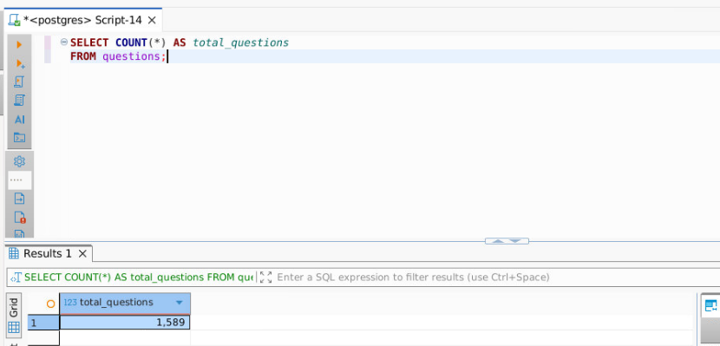
Figure7. Question Data Retrieval
Test 3: Answer Data Validation
Queries were executed against the Answer table to confirm that answer records were loaded correctly and that accepted answers could be identified using the is_accepted attribute.
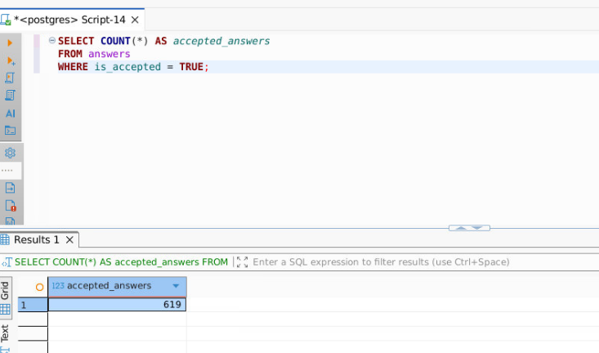
Figure8. Answer Data Validation
Test 4: Tag Data Retrieval
Queries were executed against the Tag table to retrieve tag information and verify that topic categories were available for analysis and reporting.
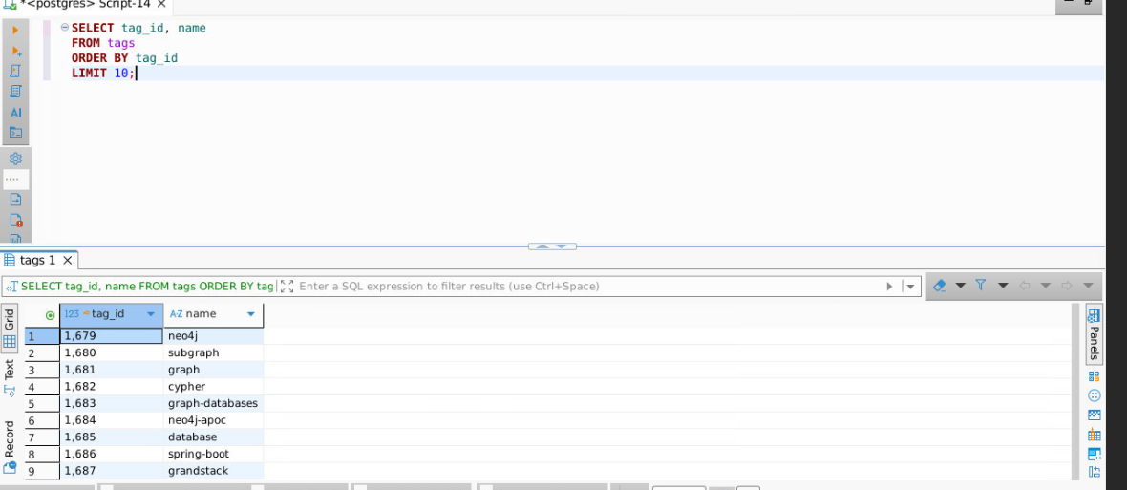
Figure9. Tag Data Retrieval
Test 5: Aggregation Testing
Aggregate functions such as COUNT() and AVG() were executed to verify that PostgreSQL could perform analytical operations on the dataset. These queries confirmed that the database supports reporting requirements for dashboard visualizations.
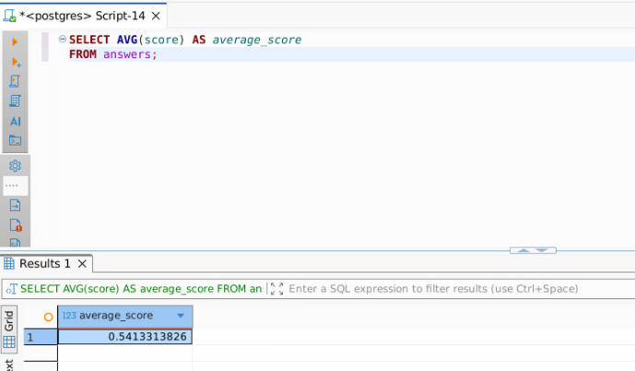
Figure10. Aggregation Testing
The successful execution of all test queries demonstrated that the database schema, imported data, and PostgreSQL environment were functioning correctly. The results verified that the database is capable of supporting analytical queries and application integration requirements.
9. Apply Database Design Techniques to Develop a Structured Database Solution
A. Data Transformation
Several data transformation activities were performed during the ETL process to ensure that the Stack Overflow dataset could be imported successfully into PostgreSQL. One issue encountered during data loading involved the User table, where the uuid column contained non-numeric values such as "deleted". Initially, the column was defined as INTEGER, which caused import failures. To resolve this issue, the uuid data type was changed to VARCHAR(50) to accommodate both numeric and text values. Additionally, CSV data was validated prior to import, column mappings were verified, and PostgreSQL data types were selected based on the characteristics of each attribute.
B. Indexing
Indexes were implemented to improve query performance and reduce search time when retrieving records from large tables. Primary key indexes were automatically created by PostgreSQL for each table. Additional indexing can be applied to frequently searched columns such as uuid and accepted_answer_id.
Example-1 indexes:
CREATE INDEX idx_users_uuid
ON users(uuid);
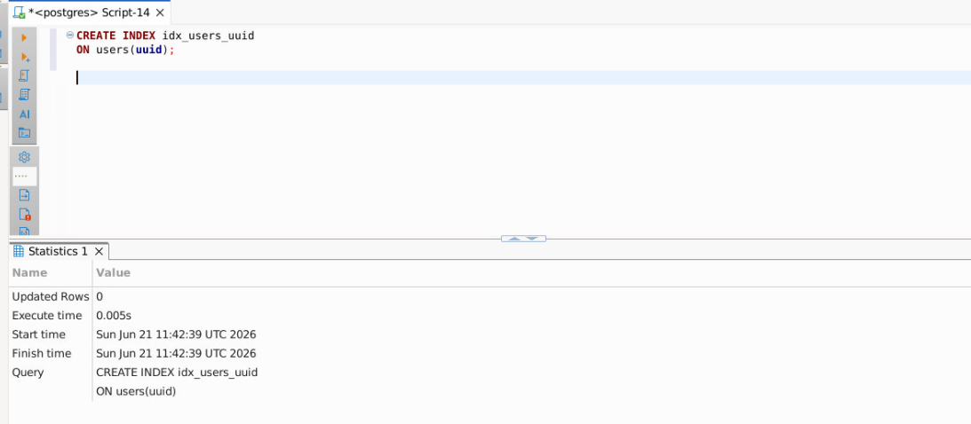
Figure11. idx_users_uuid index implementation
Example-2: indexes
CREATE INDEX idx_questions_accepted_answer
ON questions(accepted_answer_id);
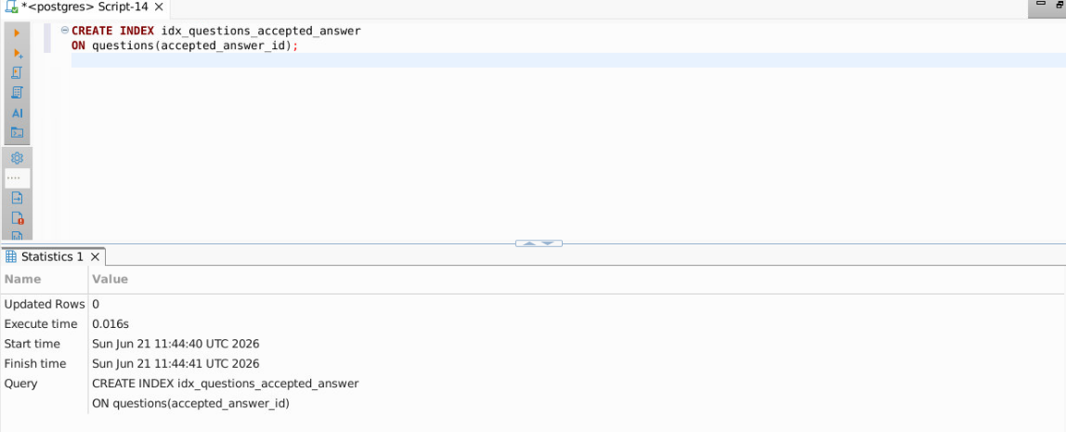
Figure12. idx_questions_accepted_answer index implementation
These indexes improve query performance by allowing PostgreSQL to locate records more efficiently without performing full table scans.
C. Normalization
The database was designed using normalization principles to reduce data redundancy and improve data integrity. Each major entity was stored in a separate table:
- Users
- Questions
- Answers
- Comments
- Tags
This design minimizes duplicate data and ensures that information is maintained in a consistent location. For example, user information is stored only in the Users table rather than being repeated in Questions, Answers, or Comments. The resulting design supports efficient storage and easier maintenance.
D. Standardization
Standardization techniques were applied throughout the database design to ensure consistency and maintainability. Table names use a consistent naming convention, primary keys are clearly identified, and similar attributes use compatible data types across tables. Standardized naming conventions improve readability and simplify future development and maintenance activities. Consistent data structures also support reliable querying and reporting throughout the database environment.
10. Identify Constraints That Can Impact Database Performance Based on Design Principles
Several constraints can impact the performance of the PostgreSQL database when processing the Stack Overflow dataset.
Large Data Volumes
As the number of questions, answers, comments, tags, and users increases, query execution times may increase. Large datasets require additional processing resources and can affect overall database performance.
Full Table Scans
Queries executed on large tables without appropriate indexes may require PostgreSQL to scan every record in the table. Full table scans can significantly increase response times, especially for analytical queries.
Large Text Fields
The Question and Answer tables contain body_markdown attributes that store large amounts of text. Processing and searching large text fields can increase memory usage and query execution time.
Complex Aggregation Queries
Analytical queries that use functions such as COUNT(), AVG(), GROUP BY, and ORDER BY may require additional processing resources when executed against large datasets.
Storage Growth
As new records are added over time, the database size will increase. Larger databases require additional disk space and may impact backup, recovery, and query performance.
Concurrent User Access
If multiple users access the database simultaneously, competition for system resources such as CPU, memory, and disk I/O may reduce overall performance.
These constraints should be considered during database design and implementation to ensure that the PostgreSQL database remains efficient, scalable, and responsive as the dataset grows.
11. Explain Mitigations That Should Be Considered to Address Performance Constraints
Several mitigation strategies can be implemented to reduce the impact of performance constraints within the PostgreSQL database environment.
Indexing
Indexes should be created on frequently searched columns to improve query performance and reduce the need for full table scans. Indexes allow PostgreSQL to locate records more efficiently and improve response times for data retrieval operations.
Query Optimization
Efficient SQL queries should be used to minimize unnecessary processing. Filtering records with appropriate WHERE clauses and selecting only required columns can reduce execution time and improve performance.
Database Maintenance
Regular database maintenance activities such as updating statistics, monitoring query performance, and removing unused objects help maintain efficient database operation.
Storage Management
Adequate disk space should be allocated to support current and future growth of the dataset. Monitoring storage utilization helps prevent performance degradation caused by insufficient storage resources.
Backup and Recovery Planning
Regular backups should be performed to protect against data loss and support disaster recovery requirements. Backup procedures ensure business continuity and reduce operational risk.
Hardware Resource Scaling
As the dataset grows, additional CPU, memory, and storage resources may be required. Scaling hardware resources helps maintain acceptable performance levels under increasing workloads.
Monitoring and Performance Tuning
Database monitoring tools should be used to identify bottlenecks, long-running queries, and resource utilization issues. Performance tuning can then be applied to improve overall system efficiency.
By implementing these mitigation strategies, the PostgreSQL database can maintain reliable performance, support future growth, and continue to provide efficient access to the Stack Overflow dataset.
12. Determine the Resource Requirements for Integration within the Selected Database Management System
A. Current and Future Size of the Data Set
The current PostgreSQL database contains data imported from the Stack Overflow dataset. The imported records include:
- Users: 1,365 records
- Tags: 476 records
- Questions: 1,589 records
- Answers: 1,367 records
- Comments: 1,396 records
These records provide sufficient data for analytical reporting, SQL query validation, and dashboard development. Although the current dataset is relatively small, future growth is expected as additional Stack Overflow data is collected and integrated into the database. As the volume of questions, answers, comments, and users increases, additional storage capacity and system resources will be required. PostgreSQL supports scalability and can efficiently manage larger datasets through indexing, optimization, and resource allocation.
B. Backups
Regular database backups are required to protect against accidental data loss, hardware failures, and database corruption. PostgreSQL provides backup and recovery tools such as pg_dump and pg_restore that allow administrators to create full database backups and restore data when necessary. Backup files should be stored in secure locations separate from the primary database server. Implementing a backup strategy helps ensure business continuity and supports disaster recovery requirements.
A complete PostgreSQL database export was created using the pg_dump utility and stored as a SQL backup file for recovery and version control purposes.
C. Performance Requirements
The database must support efficient data retrieval, analytical processing, and dashboard reporting. Performance requirements include fast query execution, reliable response times, and support for multiple concurrent users. Indexes created on frequently accessed columns improve retrieval performance and reduce query execution time. As the dataset grows, additional CPU, memory, and storage resources may be required to maintain acceptable performance levels. Continuous monitoring and optimization will help ensure that PostgreSQL remains responsive and scalable for future workloads.
13. Identify Integration Points between the Database and the Application
Several integration points exist between the PostgreSQL database and the application used for reporting and visualization.
Data Storage Integration
The PostgreSQL database serves as the central repository for storing Users, Questions, Answers, Comments, and Tags imported from the Stack Overflow dataset. All application data is retrieved from these database tables.
Query Processing Integration
The application communicates with PostgreSQL by executing SQL queries. These queries retrieve records, calculate metrics, perform aggregations, and generate analytical results required for reporting.
Dashboard Integration
The dashboard accesses PostgreSQL to retrieve data used in charts, graphs, tables, and summary statistics. Information such as question counts, answer counts, tag popularity, and user activity metrics is obtained directly from the database.
ETL Integration
The ETL process serves as an integration point between the source CSV files and PostgreSQL. Data extracted from the Stack Overflow dataset is transformed and loaded into the database before becoming available to the application.
Reporting and Visualization Integration
The application uses database query results to generate visualizations and reports. PostgreSQL provides the underlying data that supports business intelligence, trend analysis, and performance monitoring.
These integration points ensure that the application can efficiently access, analyze, and present information stored within the PostgreSQL database while maintaining data consistency and reliability.
14. Create a Storyboard of the Database-Application Integration
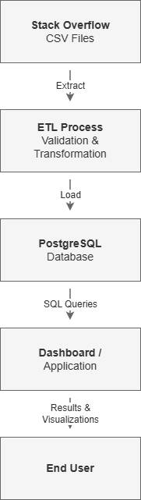
Figure13. Storyboard of Database and Application Integration
The storyboard illustrates the flow of data from the source files to the end user. The process begins with Stack Overflow CSV files that contain information about users, questions, answers, comments, and tags. During the ETL process, the data is extracted, validated, transformed, and loaded into PostgreSQL. The database serves as the central repository for storing and managing the data. SQL queries are executed against PostgreSQL to retrieve and analyze information required by the application. The dashboard then presents the results through charts, tables, and visualizations that allow users to explore trends and insights from the Stack Overflow dataset. This integration ensures efficient data management, reporting, and user interaction.
15. Explain the Security Mechanisms and Protocols for Database Protection
Protecting the PostgreSQL database is essential to ensure the confidentiality, integrity, and availability of the Stack Overflow dataset. Several security mechanisms and protocols can be implemented to safeguard the database environment.
A. Encryption
Encryption protects sensitive data from unauthorized access. PostgreSQL supports Secure Sockets Layer (SSL) and Transport Layer Security (TLS) encryption to secure data transmitted between the database server and client applications. Encryption helps prevent attackers from intercepting or reading data while it is being transferred across the network. Backup files can also be encrypted to provide additional protection for stored data.
B. Authentication
Authentication verifies the identity of users attempting to access the database. PostgreSQL supports multiple authentication methods, including password-based authentication, peer authentication, and directory-based authentication. User accounts and passwords help ensure that only authorized individuals can connect to the database. Strong password policies and regular credential management improve overall database security.
C. Authorization
Authorization determines what actions authenticated users are permitted to perform within the database. PostgreSQL uses roles and privileges to control access to database objects such as tables, views, and indexes. Permissions can be granted or revoked based on job responsibilities. For example, administrators may have full access to the database, while application users may only have permission to read data. Authorization controls help protect data from unauthorized modification or deletion.
By implementing encryption, authentication, and authorization controls, the PostgreSQL database can provide a secure environment for storing, managing, and accessing the Stack Overflow dataset while reducing the risk of unauthorized access and data breaches.
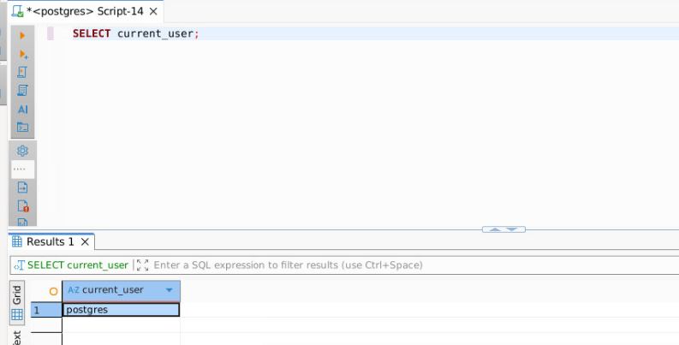
Figure14. PostgreSQL current user
16. Integrate the Database Management System with Your Application
The PostgreSQL database was successfully integrated with a Jupyter Notebook application using Python. The integration was implemented using the psycopg2 library, which enabled Python to establish a connection with the PostgreSQL database and execute SQL queries against the imported Stack Overflow dataset.
After establishing the database connection, SQL queries were executed to retrieve information from the Users, Questions, Answers, Comments, and Tags tables. The query results were loaded into Pandas DataFrames, allowing the data to be processed and prepared for visualization.
To demonstrate database integration, a dashboard was developed within Jupyter Notebook using Plotly. The dashboard retrieves data directly from PostgreSQL and displays the number of records stored in each major table. The visualization provides users with a simple and effective way to understand the contents of the database without manually executing SQL queries.
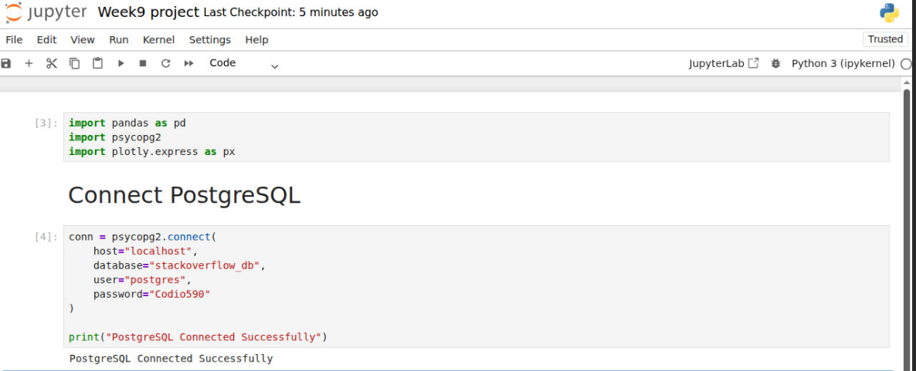
Figure15. Connecting PostgreSQL
The integration between PostgreSQL and Jupyter Notebook provides several advantages. First, the dashboard retrieves live data directly from the database, ensuring that visualizations reflect the most current information available. Second, users can analyze database information through graphical visualizations rather than writing SQL statements. Finally, the integration demonstrates how PostgreSQL can serve as the backend data repository while Python provides analytical and reporting capabilities.
A. Dashboard Screenshot
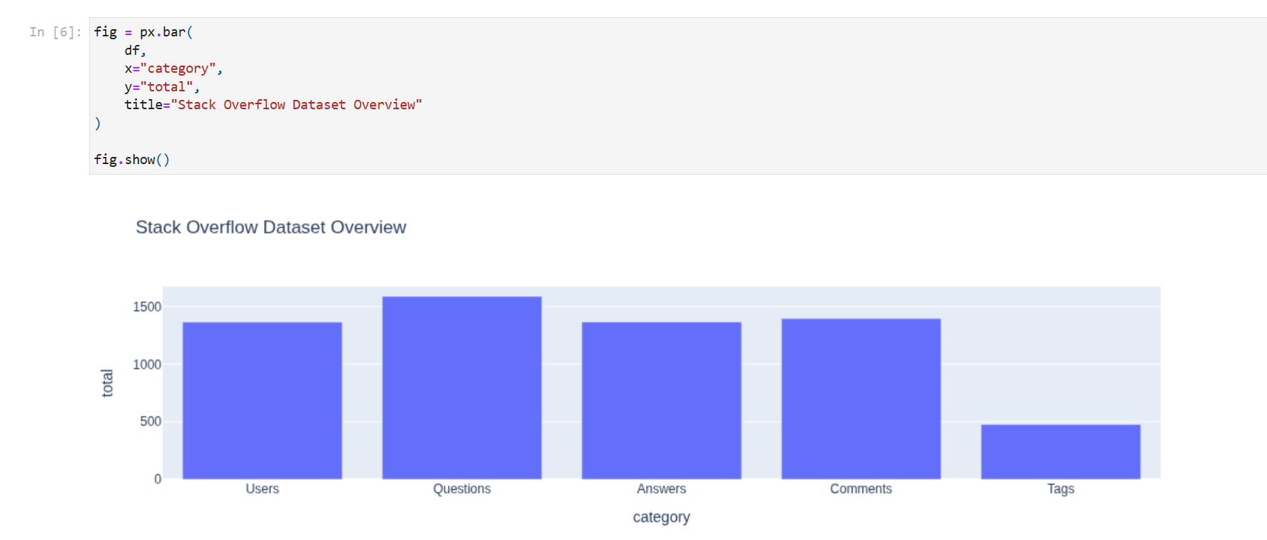
Figure16. Dashboard Bar chart
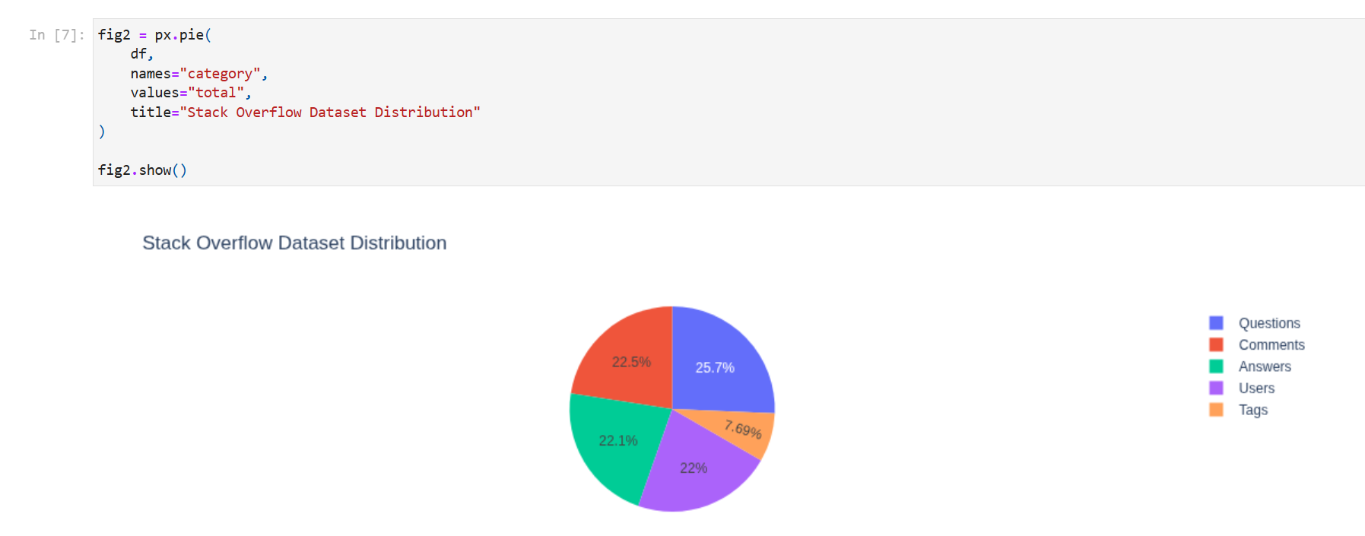
Figure17. Dashboard Pie chart
The dashboard displays a visual summary of the Stack Overflow dataset stored in PostgreSQL. The chart presents record counts for the Users, Questions, Answers, Comments, and Tags tables. The visualization confirms successful integration between PostgreSQL and the Jupyter Notebook application and provides an easy-to-understand overview of the imported dataset.
The dashboard retrieved and displayed the following database records:
- Users: 1,365
- Questions: 1,589
- Answers: 1,367
- Comments: 1,396
- Tags: 476
The successful retrieval and visualization of these records demonstrates that the PostgreSQL database and Jupyter Notebook application are fully integrated and functioning correctly.
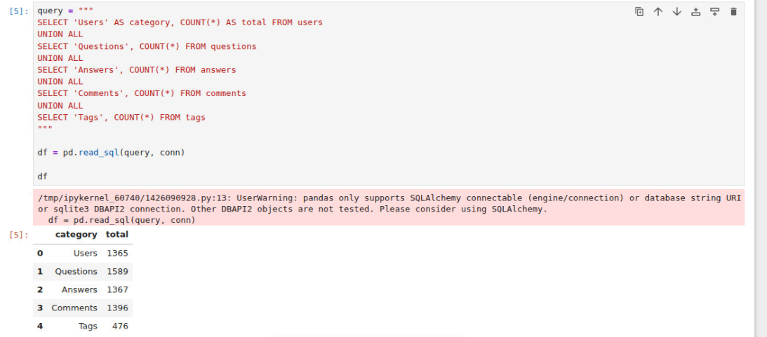
Figure18. Dashboard retrieved and displayed the database records
17. Describe the Process Used to Extract, Transform, and Load (ETL) the Data into the Selected Database Management System
The Extract, Transform, and Load (ETL) process was used to move data from the Stack Overflow CSV files into the PostgreSQL database. The ETL process ensured that the data was properly validated, transformed, and stored in a structured relational format for analysis and reporting.
Extract
The extraction phase involved obtaining the Stack Overflow dataset from the provided CSV files. The dataset contained five primary files:
- stackoverflow.nodes.User.csv
- stackoverflow.nodes.Question.csv
- stackoverflow.nodes.Answer.csv
- stackoverflow.nodes.Comment.csv
- stackoverflow.nodes.Tag.csv
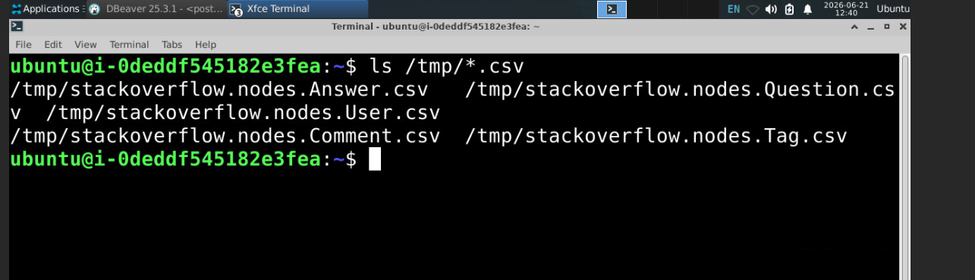
Figure19. Stack Overflow source CSV files used during the ETL process
These files contained information related to users, questions, answers, comments, and tags. The files were copied to a location accessible by PostgreSQL and prepared for import.
Transform
During the transformation phase, the data was reviewed to ensure compatibility with the PostgreSQL database schema. Column mappings were verified and appropriate PostgreSQL data types were assigned to each attribute.
A data quality issue was identified during the import of the User dataset. The uuid column contained non-numeric values such as "deleted", which caused an import error when the column was initially defined as an INTEGER data type. To resolve this issue, the uuid column was modified to VARCHAR(50), allowing both numeric and text values to be stored successfully.
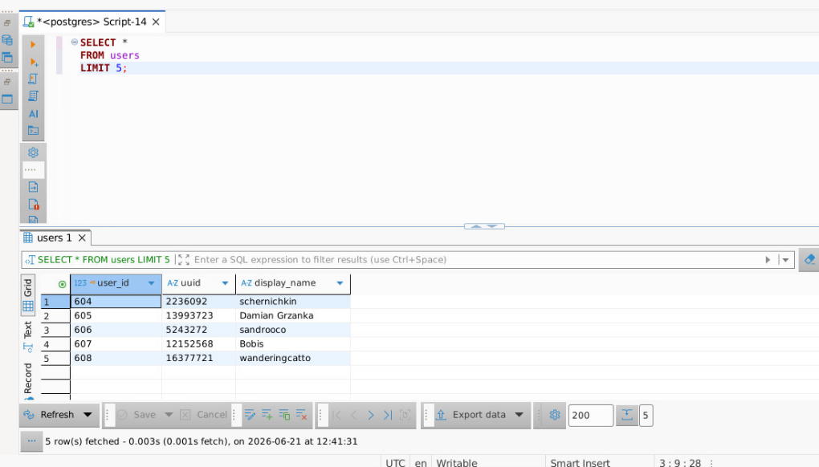
Figure20. User data validation following transformation and schema adjustments
Additional validation activities included:
- Verifying CSV column mappings
- Confirming primary key definitions
- Validating attribute data types
- Ensuring successful record imports
Load
During the load phase, PostgreSQL COPY commands were used to import data from the CSV files into the database tables. Data was loaded into the following tables:
- users
- questions
- answers
- comments
- tags
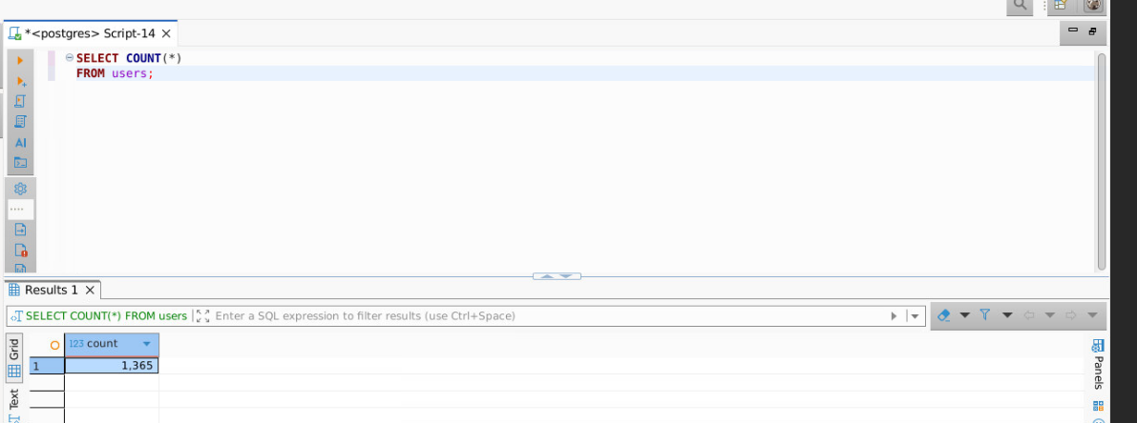
Figure21. Validation of successfully imported user records
After loading was completed, validation queries were executed to confirm successful imports and verify record counts.

Figure22, Final imported records
Final imported record counts included:
- Users: 1,365
- Questions: 1,589
- Answers: 1,367
- Comments: 1,396
- Tags: 476
The successful completion of the ETL process ensured that the Stack Overflow dataset was accurately stored within PostgreSQL and made available for querying, analysis, and dashboard visualization.
GitHub Upload Screenshot

Conclusion
This project successfully designed, implemented, tested, and integrated a PostgreSQL database solution for the Stack Overflow dataset. The database model supports efficient storage, retrieval, analysis, and reporting of questions, answers, comments, tags, and user information. ETL processes were used to import and transform the dataset, while Jupyter Notebook provided application-level integration and dashboard visualization. The final solution demonstrates database design principles, performance optimization techniques, security controls, and practical database application integration.

